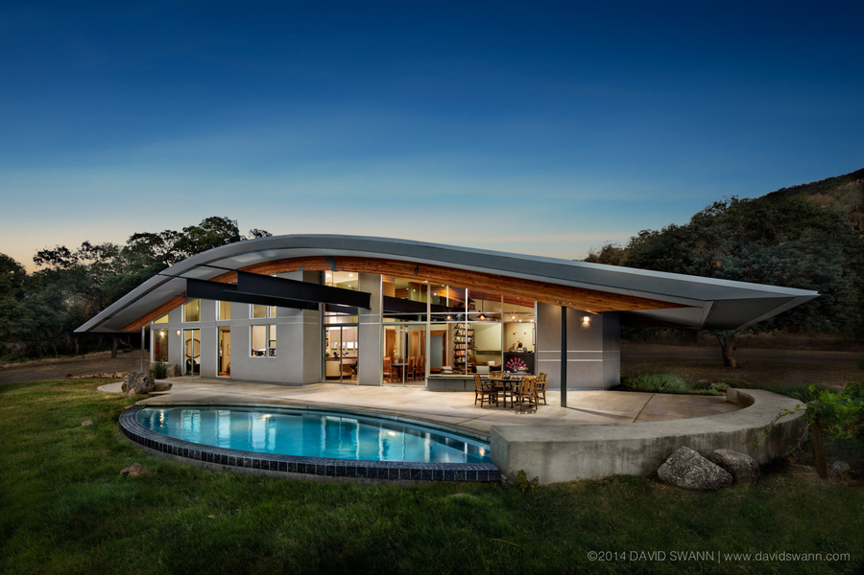

Add Comment view 2 comments
Your message


2 Comments
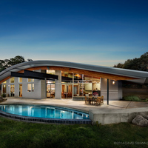
Hello David and Susan--what a wonderful shot! You really did capture the entire "ogenblik" (moment that the eye sees) on that full moon evening.
Posted 4 days ago by Deborah Lapp on LappResidence-7339WIP4.jpg
delete
Thanks David. I think that this sky looks more believable than the others. What do you think? I also like that you removed the bar-b-que unit. Perhaps you can replace it with a reclining nude on a lounge chair.
Posted 15 days ago by Arthur Dyson on LappResidence-7339WIP4.jpg
All images & content © David Swann Photography • All rights reserved

